Motor Recommendation for New Generation of Cummins’s Electric Trucks: Synchronous or Asynchronous

Luc Rulinda

Indiana University Purdue University Indianapolis

School of Engineering and Technology

3/14/2020

TCM 36000

1. EXECUTIVE SUMMARY

Cummins, an engine-maker based in Columbus, IN, is looking into leading the electric truck market in the future. To attain this, Cummins’ engineers are debating whether to power their trucks’ engines with the popular induction AC type motor used by most automotive companies, or the synchronous AC motor used by mostly foreign companies like Toyota and Honda. These two types of motors were put under the microscope to see which one meets the standards imposed by Cummins’ engineers. Although Induction motors are the most used in the electric car market, Cummins is willing to take a risk on the least favorable motor and improve it later given that it met their requirements. This research concludes that the synchronous motor presents a huge risk for Cummins to adopt it as the motor for the new generation of electric trucks. Hence, the induction motor is the proposed solution to Cummins’ engines.

1. INTRODUCTION

Cummins has gained a reputation as one of the most successful and reliable engine manufacturers in the world. Cummins founded in 1883, is most known for its diesel engines which have won many awards. Part of their innovation plans going forward, Cummins’ engineers have been focusing on electric powered trucks as a solution to the current environmental crisis. Tony Lukabya, one of the Senior engineers at Cummins must decide on what type of electric motor that should power the new generation of fully electric heavy-duty trucks at Cummins. His team has narrowed down to two electric motor options: synchronous and asynchronous motors. Tony assigned the task of conducting a research comparing these two motors, then to recommend the most optimal one that Cummins should implement for their new generation of electric trucks.

Electric trucks require electric motors to power their vehicles and this left a challenge of figuring out the most optimal and efficient motor out of the various types already available. Thus, this paper will focus on two types of electric motors- synchronous motors and asynchronous motors (also known as induction motors)- their implications. The recommendation at the end of this research will consider multiple research papers already published on electric motors and on a diligent consideration of the few electric trucks available on the market.

One constraint to this research is that there are few electric trucks on the market, and even fewer publication on the specifications and details of the motors powering them. This paper consists of studying the differences in the Induction and synchronous motors, and finally pick one that proves to be the most efficient for Cummins’ trucks.

1. ANALYSIS

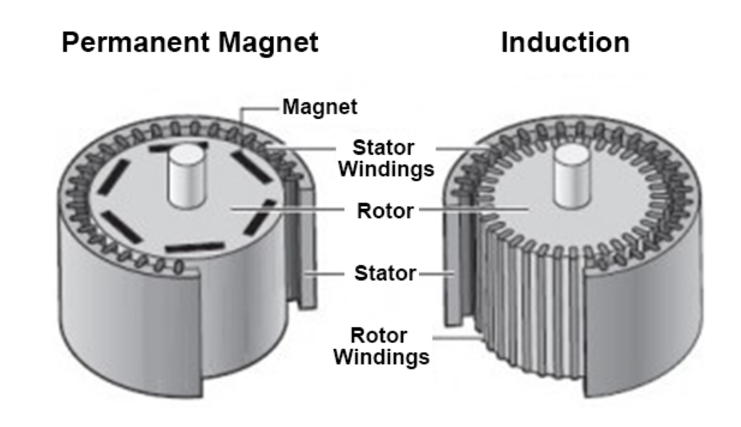

Figure 1. Induction and synchronous motors (June 2004)

Synchronous motors and Induction motors (asynchronous motors) have very explicit differences and applications but each one of them has advantages and disadvantages when it comes to powering vehicles. In order to choose the most favorable motor we need to first assess Cummins’ needs and expectations in a motor. Tony Lukabya gave the following as the most important factors to choosing a motor at Cummins: characteristics at high speed, cost of production, reliability, maintenance, noise and lifetime. Tony stressed the fact that Cummins is willing to take a risk on the less popular type of motor if it has a good performance and other favorable characteristics that an engineer would like in a motor.

An induction motor is an alternate current electric motor in which the electric current in the rotor that produces torque is obtained by electromagnetic induction from the magnetic field of the stressor winding [1]. Hence, an induction motor doesn’t need any wiring to its rotor. On the other hand, there is the synchronous motor is also an AC motor in which at steady state the rotation of its shaft is synchronized with the frequency of the source current. The rotation period of the shaft is equal to an integral number of AC cycles [1].

The biggest advantage of a synchronous motor is the minimal noise it emits, this was the main reason Toyota mainly favors synchronous motors over induction ones [2]. A big disadvantage of the later however, is it the maintenance cost. Synchronous motors are expensive to maintain due to the complexity of its mechanism since its rotor needs to be in-tune with the electric AC current. This is a considerable problem given the fluctuation of the electric current in the battery of a car [2]. Batteries are one of the most expensive components in any electric car because its quality dictates the mechanism of its motor. Hence, an impeccable synchronous motor demands an expensive car battery which is not the case with induction motors.

When asked the reason of the choice in motor, most automotive engineers who favor the induction motor point to its reliability [3]. Companies want to position themselves as the leader in the electric automotive industry and this is synonymous to making the most reliable cars on the market. 75% of electric cars on the market are powered by induction motors. This is because induction motors require close to no maintenance [1].

1. RESEARCH
2. *Characteristics at high speeds*

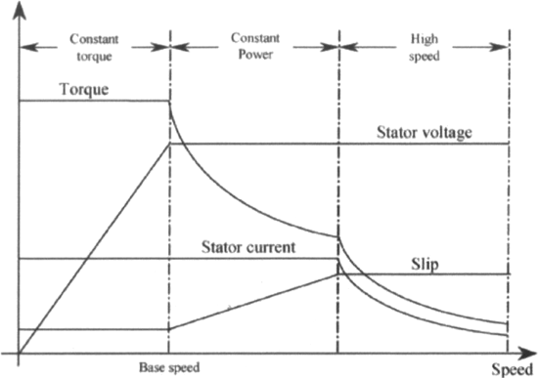

Figure 1: Different characteristics of induction motors (1988)

Above is a figure that shows the torque characteristics of an induction motor at high speeds. Induction motors are the most used in the electric car market but have poor torque performance at high speeds [5]. One can see that there is not that much torque at high speed, this would even be worse for the size of the load Cummins’ trucks carry.

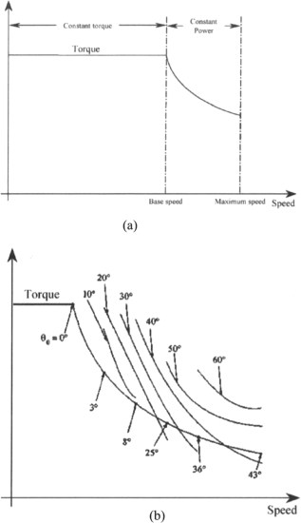

Figure 2. Torque-speed characteristic of a synchronous motor (1988)

Above is the characteristic of a synchronous motor, the latter is used by car manufacturers such as Toyota and Nissan [3]. Unlike the induction motor, one can see that its torque is constant before the motor reaches the base speed. This is an advantage over the induction motor because the variation in torque tires the motor especially when it’s varying before it even reaches the base speed as portrayed in [2] and [3]. This results into a better motor efficiency and better effective distribution of heat into the environment.

1. *Power output*

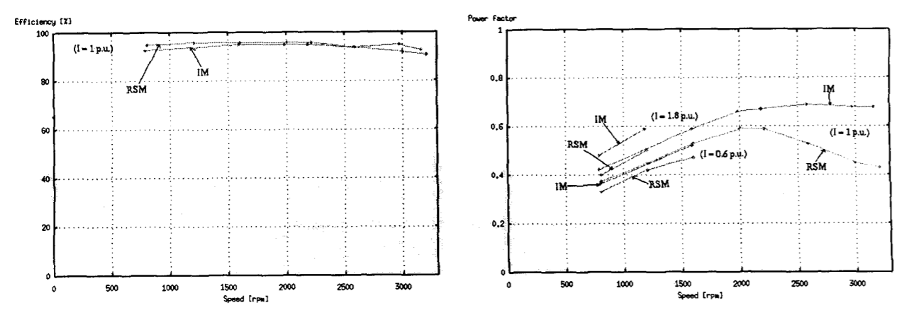Figure 3. Measured motor efficiency versus speed comparison (May 2000)

Figure 4. Measured power factor versus speed comparison (May 2000)

The above graphs are the results of a study conducted by the department of mechanical engineering at the University of Stellenboach [4]. One can observe from figure 3 that the synchronous motor (RSM) has a higher efficiency than the induction motor before they both reach high speeds. The induction motor has a clear advantage over the synchronous one when it comes to high speed. The former also has a higher power factor at any speed [5].

1. RECOMMENDATION

The induction type of AC motor is the most popular type in the electrical market for a lot of reasons including a higher efficiency and power factor [6]. These two are the most important characteristic when it comes down to choosing a motor. The induction motor performs very well at high speeds and at a longer duration. This is very important given the distance and speeds at which heavy-duty trucks are needed to run.

Although the synchronous motor possesses some advantages like lower noise and an excellent torque at a high speed, it represents a lot of risk for Cummins to take that chance with their next truck models. Synchronous motors will cost Cummins its reputation because of how unreliable they are. They demand a lot of maintenance the longer they run, and this might result in lawsuits, discontent customers and eventually a bad reputation for the brand. My recommendation is for Cummins to produce induction motor vehicles and invest heavily into improving the weaknesses it represents. Below is a table that compares results of the research between the induction and synchronous motors given the standards given by Tony Lukabya.

Table I. RESPECTIVE ADVANTAGES OF THE INDUCTION AND SYNCHR0NOUS MOTOR



The table above clearly shows that the induction motor is the most advantageous motor for Cummins’ requirements. The implications of the advantages of the synchronous motor do not compare to those of the induction motor since the motor efficiency and maintenance cost of a motor are more important than its noise and torque. Both motors have approximately the same cost of production so there is no favorable motor for that characteristic.

1. CONCLUSION

Multiple research studies have supported the induction AC motor for its favorable features. Although the synchronous motor has some advantages over the later, the induction motor is clearly the better motor given its reliable performance. There is no point of having a silent but unreliable motor, or a motor with excellent torque at high speeds but very expensive to maintain. Betting on the synchronous motor at the current level of technology would be a bold but unreasonable decision. Other companies including the successful ones like Tesla are adopting the induction motors because of the less risks it represents for them and their customers.

Going forward, the next step for Cummins’ engineers is to invest heavily in research and development to improve on the weaknesses the induction motor displays. The results to this investment will reflect in the good quality of their electric trucks throughout the years.

REFERENCES

1. R. S. Colby and D. W. Novotny, "An efficiency-optimizing permanent-magnet synchronous motor drive," in IEEE Transactions on Industry Applications, vol. 24, no. 3, pp. 462-469, June 1988.
2. P. Gaynor, (2010). 2010 Record of Conference Papers Industry Applications Society 57th Annual Petroleum and Chemical Industry Conference (pp. 1-9). IEEE.
3. P. Gaynor and R. Krusemark, "Induction vs. synchronous motors — Different perspectives end user/motor manufacturer," 2010 Record of Conference Papers Industry Applications Society 57th Annual Petroleum and Chemical Industry Conference (PCIC), San Antonio, TX, 2010, pp. 1-10.
4. Germishuizen and M. J. Kamper, "Performance comparison of reluctance synchronous and induction traction drives for electrical multiple units," Conference Record of the 2000 IEEE Industry Applications Conference. Thirty-Fifth IAS Annual Meeting and World Conference on Industrial Applications of Electrical Energy (Cat. No.00CH37129), pp. 316-323 vol.1. May 2000
5. K. Kurihara and M. A. Rahman, "High-efficiency line-start interior permanent-magnet synchronous motors," in IEEE Transactions on Industry Applications, vol. 40, no. 3, pp. 789-796, June 2004.
6. N. Hashemnia and B. Asaei, "Comparative study of using different electric motors in the electric vehicles," 2008 18th International Conference on Electrical Machines, Vilamoura. February 2008